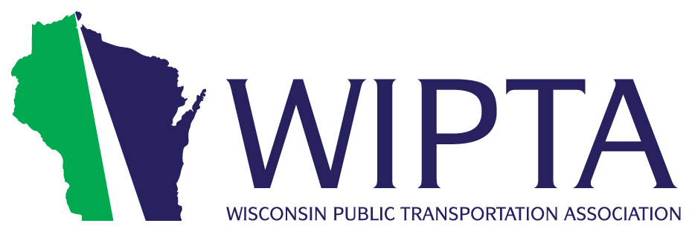
WIPTA Overview
The Wisconsin Public Transportation Association (WIPTA) represents all of Wisconsin’s local bus systems, 45 shared-ride taxi services, and numerous partners and stakeholders.
Transit is an increasingly necessary and popular way for Wisconsin’s citizens to get to work, get to school, and even for social travel. Transit is also vital to our aging community for access to shopping, community centers, and medical appointments.
Now more than ever, transit infrastructure is an important prerequisite for businesses to relocate or expand in a state or given community. Businesses are constantly requesting our systems to increase service and even dedicate routes. But under current funding levels, it is not possible to accommodate these demands.
Importantly, in both rural and suburban communities, transit is crucial for meeting the demands of seniors who wish to stay in their homes and communities.
Adequate state and federal investment is critical to meeting the market demand for public transit. Public transit is vital to our economic growth and for delivering reliable transportation options to our urban, rural, young, and aging riders especially for work and school.
Approximately 30% of the statewide transit fleet is past its useful life and previous cuts to operational assistance have not been restored. Like transportation infrastructure, transit requires appropriate investment to spur and maintain job growth and provide the service our communities require.
According to Wisconsin DOT:
Transit in Wisconsin provides:
- 33 million rides to work (55%)
- 8.4 million education-related trips (14%)
- 12 million social rides like shopping tourism, recreation (20%)
- 6.6 million trips for healthcare purposes (11%)
Annual transit expenditures amount to approximately $314 million:
- Passenger Revenue: 34%
- Federal Funding: 18%
- State Funding: 32%
- Local Funding: 16%
Every dollar invested in public transit by a community results in a three-dollar return.

