**2019 Statistics**

321,834 Total Fixed Route Rides

6,860 Total Paratransit Rides

357,863 Revenue Miles

372,594 Total Miles

7 Fixed Routes

9 - Bus Fleet

6 - 35’ 2019 Gillig Buses

1 - 35’ 2020 Gillig Bus

2 - 29’ Buses that will be replaced with 35’ Gilligs in Summer of 2021

20 Employees

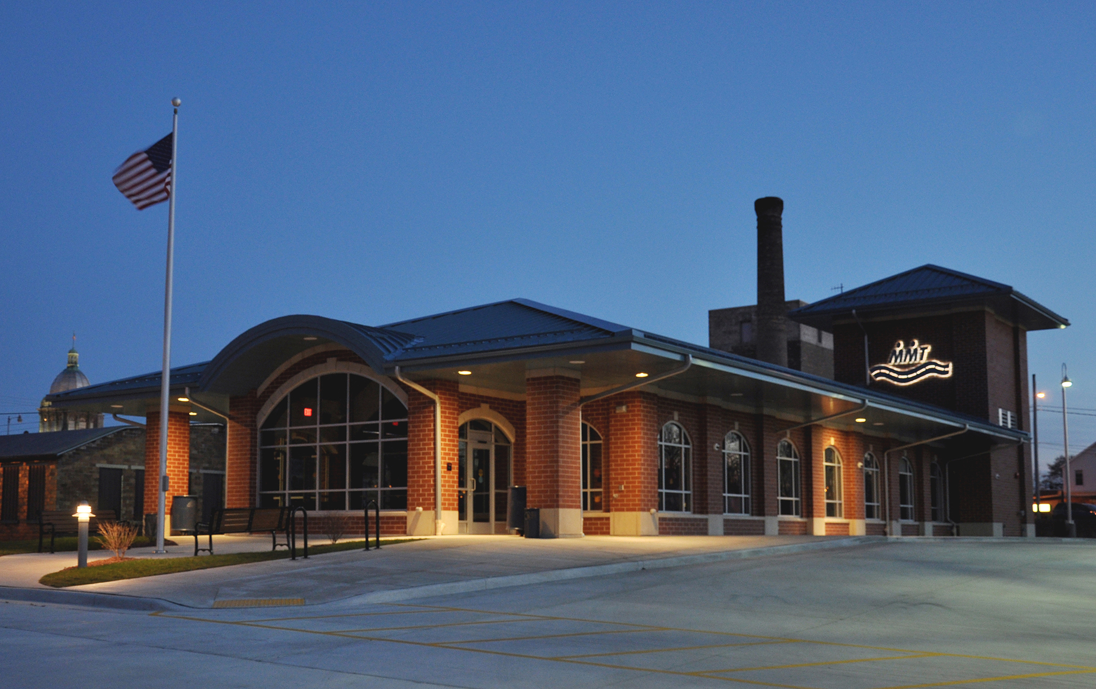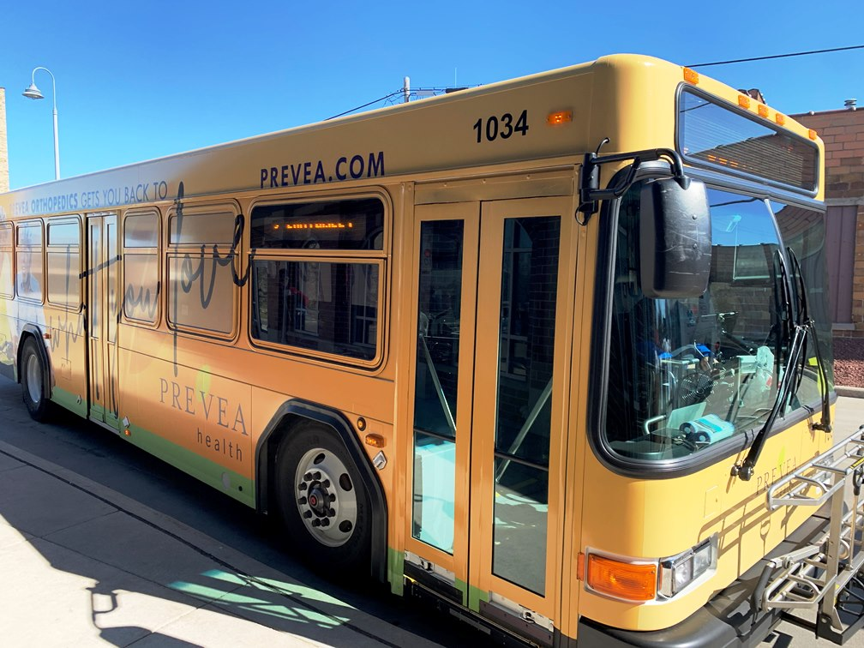

Our Transit System

Maritime Metro provides public transportation to the cities of Manitowoc and Two Rivers. We have seven fixed routes that run from 5:00AM – 8:00PM Monday thru Friday. We also run six fixed routes on Saturday from 9:00AM – 4:00PM

Maritime Metro Transit through coordination with Manitowoc County offers specialized transportation services for residents throughout Manitowoc County. Everyone should have access to public transportation to get where they need to go. Since 1978, Manitowoc Transit and now Maritime Metro Transit have been providing fixed route bus service to the cities of Manitowoc and Two Rivers. In 1992, under the Americans with Disabilities Act (ADA), Maritime Metro Transit began providing paratransit service. Through the coordination of specialized transportation services, passengers living throughout Manitowoc County and in the Cities of Manitowoc and Two Rivers have many transportation options.

**MMT** **Contact Information**

915 South 11th Street (920)686-3560 - Mainline

Manitowoc, Wisconsin 54220 (920)686-5020 - Fax

www.manitowoc.org [metro@manitowoc.org](mailto:metro@manitowoc.org)